Snapshot Workflow, Management Information

Background

Across much of sub-Saharan Africa, malaria is the biggest killer. This is especially
the case for pregnant mothers and children under 5. The specific need that this project addresses is the lack of visibility of the stock level of ACTs in public health facilities. The result of this lack of information within the distribution network is that at times these health facilities experience “stock-outs” (no drug in stock) and have to find alternative means of providing the drug to patients
(alternative sources, subdivision of larger packs, etc).

This solution shall demonstrate:
- A means by which health facilities can provide regular updates to the coordinators of the supply chain on their stock of medications.
- Deliver a means for those coordinators to view the stock information thus obtained.
- Permit each health facility to indicate, by means of an SMS message, its stock of drugs each week
- The identity of each health facility must be provided or captured for each SMS message.
- Provide reporting to authorised system users, via web interface. Escalation where communication is not received from a Health Facility

How the business will use the solution

Snapshot will be deployed as a web based application and configured to enable the storage of Health Facility locations, the mobile numbers attached to each and will transmit weekly SMS messages to each and expect a response by SMS.
District Medical Officers will be able to add and delete mobile phone numbers attached to a Health Facility.
Statistical users will be able to log into the web application to view Management Information.

Communication Processes

There will be a weekly SMS process to collect and analyse data

Data Request to Health Facility

The different types of drugs are colour coded to aid with identification The system will use the colours to report the number of units in the weekly SMS, namely
- Red – R (mandatory)
- Green – G (mandatory)
- Blue - B (mandatory)
- Yellow – Y (mandatory)

- The expected response from a Health Facility would be: “R5G12B4Y23Q2“
- The expected response will be an Alpha character followed by a number
- Ignore lower case letters, spaces
- R G B Y are mandatory

If the response does not satisfy the above criteria, respond with an error message. No submission to the data will take place until a correctly formatted message is received.
Store the number of times an incorrect message has been received. If on the 3rd attempt the message is still incorrect, an email is sent to the Stock Manager and cc’d to the defined Gov’t official

Validation

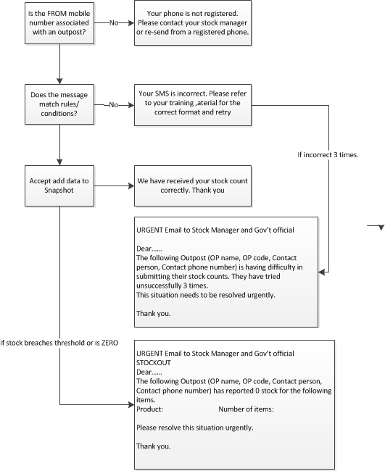

Schedule

- XXpm Thursday – Send SMS to each Health Facility requesting stock levels
- XXpm Friday – If no SMS received from the Health Facility, send the reminder SMS
- Allow submissions after this date/time until the following Thursday at 1pm
- XXpm Monday – If no SMS received from the Health Facility, notify the Stock Manager and cc Gov’t Official of no response.

Stock Manager – Adding a Health Facility phone number via SMS

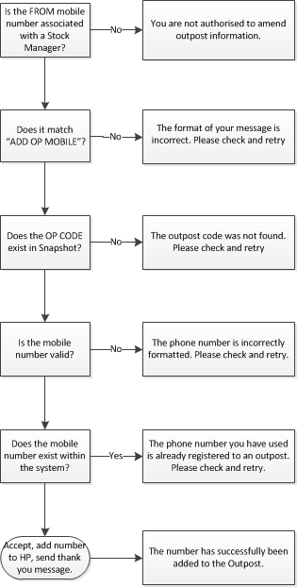

Stock Manager – Removing a Health Facility phone number by SMS

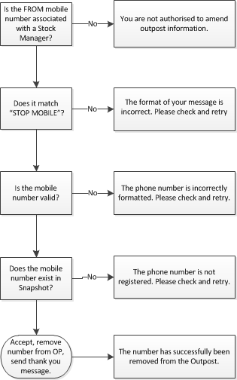

Information to capture

- Forename, Surname, Business Name, Post Code etc
- Outpost ID
- Outpost Name
- Outpost co-ordinates (log/lat)
- Mobile phone number
- Region
- District
- Submission date/time
- Drug stock level
- Red – R (mandatory)
- Green – G (mandatory)
- Blue - B (mandatory)
- Yellow – Y (mandatory)

